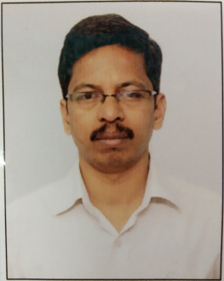
Name: Suresh Pandharinath Kadam
Designation: Lecturer in Mechanical Engineering
Date of Birth: 20th Jan. 1980
Email: sp.vjti@gmail.com
Employee ID: DTESPKM8001
Educational Qualification Details:
SSC Board Name | SSC CLASS OBTAINED | HSC BOARD NAME | HSC CLASS OBTAINED | BE UNIVERSITY NAME | BE CLASS OBTAINED
Kolhapur | Distinction | Kolhapur | First | Pune | First
ME UNIVERSITY NAME | ME CLASS OBTAINED | PHD UNIVERSITY NAME | PHD CLASS OBTAINED
Mumbai | Distinction

Teaching Experience Details:
Approval Status (Y/N) | Name of Appointing Authority | Date of joining | Teaching Experience  (No. of Years)
Yes | Directorate of Technical Education | 01st Mar. 2011 | 14
STTP/FDP/Industrial Training/MOOCS/workshop/conference attended etc. Details:
Sr. No. | Name of STTP/FDP / Industrial Training /MOOCS etc | Place | Date | Duration (days/weeks)
01 | Induction Phase-I | G. P. Mumbai | 18/4/2011-29/4/2011 | 2 weeks
02 | Induction Phase-II | NITTTR Bhopal | 18/6/2012-29/6/2012 | 2 weeks
03 | AutoCAD | G. P. Pune | 13/06/2011-26/06/2011 | 2 week
04 | Copyright, IPR & Patents in India | G. P. Nasik | 08/07/2013-12/07/2013 | 1 week
05 | Finite element analysis of Mechanical, Thermal & Fluid Systems | G. P. Karad  (TEQIP) | 23/06/2014-27/06/2014 | 1 week
06 | Advanced techniques in Quality Assurance and Improvement | G. P. Thane | 14/01/2013- 18/01/2013 | 1 week
07 | Foundation training | YASHADA, Pune. | 30/12/2013-08/02/2014 | 6 week
08 | Plastic Processing | CIPET Chh. Sambhajinagar | 30/12/2024-03/01/2025 | 1 week
09 | Operation & Maintenance of heavy machineries in large scale Industries | Adani Thermal Power Plant Dahanu, Palghar | 10/02/2025-14/02/2025 | 1 week
Details of Research Paper/ conference Papers/ Journal Papers Published:
Sr. No. | Title of Paper Published | Publication Details
Research Interest: - CAD CAM, Manufacturing
Membership of Professional Societies: - Nil
Industrial experience in years – 03 Years (L & T Mumbai)

